In This Issue …
Redeemer Lutheran Church
of Leisure World
13564 St. Andrews Drive
Seal Beach, California 90740
ADDRESS SERVICE REQUESTED
Article Page
January 2020
Message from the Pastor 1-2
Emergency Pastoral Care 2
President’s Message 3-4
Those Who Serve 5
Birthdays and Anniversaries 6
Sealed Pledges 6
Our Budget and Expenses 7
Offering Envelopes 7
Remember in Prayer 8
Bible Study 9
New Year’s Day Service 9
Annual Reports 9
Save the Date for Installation 10
Monthly Calendar Center
InterFaith Annual Gala 11
Annual Meeting Announcement 12
Membership Directory 12
Annual Personal Giving Reports 13
Year End Giving 13
Christmas Outreach Thank You 13
Thank You for Holiday Cookies 13
2020 Church Council Members 14
Mission Moment 15
Non-profit Org.
U S Postage
PAID
Long Beach, CA
90815
Permit No. 70008
Outreach Team 15
Lessons to Study 16
Flowers 17
Worship and Discipleship 18-19
Office Information 20


From Pastor Lisa Rotchford …
Redeemer Lutheran Church
of Leisure World
13564 St. Andrews Drive
Seal Beach, CA 90740
Phone: (562) 598 - 8697
FAX: (562) 598 - 8697
E-mail: redeemer_lutheran@verizon.net
Website: www.redeemerlutheransealbeach.com

“A New Year…A New Beginning”

Dear Family and Friends:

Our New Year of our Lord 2020 brings with it the added bonus of the “fresh start” of a new decade — the third of this 21st century. Can you believe it? It seems like a few weeks ago we celebrated the new millennium and now we have added a new decade to our history books. What will the new year and the new decade bring?

When you think about it, every day is the start of a new year you don’t have to wait for the calendar to say “fresh start”. Every morning is a fresh start and every evening a chance to remember the past day and look forward to the new day (and year!) beginning each and every tomorrow.

While the world encourages us to make “New Years’ Resolutions”, our faith can be strengthened by resolving to walking closer with Our Lord every day.

Our Lord Jesus Christ gives us that fresh start each and every day.

How would our days look differently — new and fresh — if we began each morning with reading The Good News before the world’s news?

Church Office Hours: 10:00 a.m. to 1:00 p.m.
Tuesdays and Thursdays.
Please call and leave a message at all other times.
Sunday Worship: 10:30 a.m. Traditional Service
(Holy Communion on first and third Sundays)
Bible Study: 10:30 a.m. Wednesdays – Conference Room
Holy Communion and Healing Service: 11:30 a.m. Wednesdays – Sanctuary
Outreach Visitation: 2:00 p.m. the Last Tuesday of the Month – Conference Room
Council Meeting: 2:30 p.m. the 4th Thursday of the Month – Conference Room
Respite Care: 9:30 a.m. to 3:30 p.m.
Monday, Tuesdays and Thursdays
Food Donations: Mickey Costello, Carl and Jessica Keene
Church Staff
Pastor: Rev. Lisa Rotchford
phone is (714) 833-7332
Secretary: Margo Geesing
Organist: Sharon Heck
John the Baptist appears again in the Gospel of Matthew on the second Sunday of January as he witnesses to the light of the Christ as he baptizes Jesus. This is the beginning of Jesus’s public ministry. This is the second instance of the Trinity, (although more overt) when Jesus comes up from the baptism, “And when Jesus had been baptized, just as he came up from the water, suddenly the heavens were opened to him and he saw the Spirit of God descending like a dove and alighting on him. And a voice from heaven said, ‘This is my Son, the Beloved, with whom I am well pleased.’” This was shouted by the heavens that Jesus was being baptized! His mission was beginning! His hidden days are over – his private life is done!! It’s all out in the public from here on out. How did your baptism change your life? Has your identity as a follower of Christ become public? Does anyone (other than the ones you go to church with) know you follow Christ? Does this identity change how you live your life?
John focuses his followers on the Lamb of God – Jesus. Two of John’s followers began following Jesus, who calls them to come and see, rather than explaining who he was. They came and saw, and began spreading the word of who Jesus IS: the Messiah! And through one of the first of John’s followers, we come to Peter being called into following Jesus. Who showed you Jesus? How did you come to know him? Who are you showing Jesus to?
The last Sunday of January Jesus fulfills what we hear in the first lesson from Isaiah: “…the people who sat in darkness have seen a great light, and for those who sat in the region and shadow of death light has dawned.” He is the light that has come. How are you called to be a disciple? How are you sharing the Good News and shining your light towards Christ?
Every dawn in Christ is a New Beginning. How would our day be brightened like the dawn by letting the love of Christ enter into our morning by prayer — a conversation with our Lord?

One of the older hymns of the church — found in writings of a 13th century saint, Richard of Chichester, England — was a song revitalized 5 decades ago in a play entitled “Godspell” — a play based on the Gospel of Matthew.

Day by day,
Dear Lord, of thee three things I pray:
To see thee more clearly,
Love thee more dearly,
Follow thee more nearly,
Day by day.

Words to sing and live by. God, by your grace, love and mercy, may we enter each New Day of this New Year by seeing you, loving you and following you closer, Day by Day.

In Jesus Name we pray,

Pastor Lisa

Emergency Pastoral Care: Whenever you are in need of emergency pastoral care give Pastor Lisa a phone call (714) 833-7332. Jerry Brady and Margo Geesing (our secretary) also know how to reach Pastor Lisa.

Message from Our President …

Dear Members and Friends:

My sincere gratitude and thanks go to the members of Redeemer’s Church Council who have so faithfully served the Lord in this past year. They include Carmen Leslie, Vice-President; Dena Anderson, Secretary; Phyliss Mackey, Treasurer; Kay Pushman, Financial Chair; and Terry Durham, Cedric Elmer, Karen Ford, Debbie Hugdahl, Chris Moore, Maria Swift, and Juanita Townsend.

This was a most eventful year for Redeemer Lutheran Church. After over 16 years of dedicated service, Pastor Gil Moore delivered his farewell sermon on Sunday, April 28 with Bishop Andy Taylor addressing the congregation and a wonderful luncheon following.

Karen Ford and Brian Holland represented Redeemer at the Annual Pacifica Synod Assembly May 10 and 11 at Hope Lutheran Church in Palm Desert.

St. Theodore Episcopal Church continued our very good relationship with Sunday Worship in our
Reflections on WORSHIP
and DISCIPLESHIP by Margo Geesing
“The Light of Jesus”
We have almost finished with the time of Christmas and are beginning of the Time after Epiphany. The first Sunday of January we hear the beginning of the Gospel of John: “In the beginning was the Word, and the Word was with God, and the Word was God”; our first of two instances of the Trinity in this month’s Gospels. It is also the introduction of John the Baptist in this Gospel. John is the announcer of the light, but not the light himself. This Gospel is a reminder of who Jesus is: light to the world; God and the Son of the Father; full of grace and truth; there from the beginning of creation; and through whom we know the Father. How do you see Jesus in his many roles? Do you remember that he is God or do you only recognize him as the baby who became a man? Do you share that light of the Christ with the world (or at least your part of it)?
The first Monday of January we celebrate Epiphany. There are many symbols related to this day: a star, gifts, crowns, magi, and light. My focus will be on that star and the light it shines in darkness. Christmas is the celebration of Jesus’s birth and coming to the Jewish people. Epiphany is the celebration of Jesus’s birth announcement to the world as represented by the Magi. They have been following the light of the Christ before they even arrived at the side of the Savior. As we begin our Time after Epiphany, let us reflect on what light we follow. How do you follow the light: through history; through science; listening to experts; through studying; through prayer? All are valid ways but a combination is a viable choice. Following Christ’s light must include prayer.

Altar Flowers for January
January 5th:
Poinsettias
January 12th:
Open
January 19th:
Open
January 26th:
Open

Flower Chart Directions
- There are 2 bouquets for each Sunday.
- Print your name and the special reason for the request on the line next to the date you would like them.
- If there is not enough room to write your request on the chart, please leave the secretary a note in her box specifying your request.
- The requested donation for one bouquet is $15.00; $30.00 for both.

If you wish to request both bouquets, please note that on the chart.
When putting your donation in an envelope, please note that it is for altar flowers and the date of your flowers. Please write a separate check for flowers. Do not include it with your regular offering.
Sanctuary following our Lutheran Service. Our thanks to them for the beautiful new chairs and conference table they donated for our many meetings.

On Sunday, June 2, an invitation to serve was extended to Rev. Lisa Rotchford by our congregation to become Redeemer’s new Pastor. She has been serving us since then. Her official installation won’t be until February 16 because of scheduling conflicts. Pastor Lisa has initiated a new mid-week Chapel worship every Wednesday at 11:30 a.m. as well as adding services on Thanksgiving and Christmas Day.

Pastor Lynda Elmer continues our weekly Bible Study on Wednesdays at 10:30 a.m. They are now being held in our conference room.

New Officers will be elected at our January 23 Church Council Meeting.

God bless you all,
Jerry Brady
President



THOSE WHO SERVE
THIS MONTH
Please study the following at home to prepare for Sunday Worship:
Lessons for Second Sunday of Christmas
through the 5th Sunday after Epiphany

Newsletter Assembly

Sara Gould

Maria Swift

Dee Sessa

Altar Guild

Carol Costello

Alice Dokter

Betty Lucero

Sylvia Makus

Financial Team
5th: Christa Diesslin
Flo Nesland
Alma Zamzow
12th: Wendy Alfageme
Rose Kroll
Alma Zamzow
19th: Christa Diesslin
Flo Nesland
Alma Zamzow
26th: Wendy Alfageme
Rose Kroll
Alma Zamzow

Acolyte

Carmen Leslie

Communion Assistant

Jerry Brady

Greeter
Nancy Anderson
Reader

Juanita Townsend

Prayer Leader

Carol Costello

Ushers
Maria Swift
Choir

Beverly Anderson

Dondi Buchrucker

Lynda Elmer

Karen Ford

Debbie Hugdahl

Chris Moore

Kay Pushman

Violet Quist

Shirley Reimers

Join us – there is always space for more voices!
January 5, 2020 – Second Sunday of Christmas
Jeremiah 31:7-14
Sirach 24:1-12 (Alternate)
Psalm 147:12-20
Wisdom 10:15-21 (Alternate)
Ephesians 1:3-14
John 1: 1-18

January 6, 2020 – Epiphany of Our Lord
Isaiah 60:1-6
Psalm 72:1-7, 10-14
Ephesians 3:1-12
Matthew 2:1-12

January 12, 2020 – Baptism of Our Lord
Isaiah 42:1-9
Psalm 29
Acts 10:34-43
Matthew 3:13-17

January 19, 2020 – Second Sunday after Epiphany
Isaiah 49:1-7
Psalm 40:1-11
1 Corinthians 1:1-9
John 1:29-42
January 26, 2020 – Third Sunday after Epiphany
Isaiah 9:1-4
Psalm 27:1, 4-9
1 Corinthians 1:10-18
Matthew 4:12-23

February 2, 2020 – Fourth Sunday after Epiphany
Micah 6:1-8
Psalm 15
1 Corinthians 1:18-31
Matthew 5:1-12

February 2, 2020 – Presentation of Our Lord
Malachi 3:1-4
Psalm 84
Psalm 24:7-10 (Alternate)
Hebrews 2:14-18
Luke 2:22-40

February 9, 2020 – Fifth Sunday after Epiphany
Isaiah 58:1-12
Psalm 112:1-10
1 Corinthians 2:1-16
Matthew 5:13-20



Global Mission Call ~~
On the last Sunday of each month we take a moment to reflect on our call to serve all of God’s people.
Our next Mission Moment is January 26th.

The Outreach Team meets on the last Tuesday of each month in the Conference Room at 2:00 p.m.


This month we will meet on
January 28th at 2:00 pm!

“Whatever you do for the least of my brothers and sisters, you do for me.”
(Matthew 25:40)

We are Calling All People who like to talk, visit, go out, talk about our church, and be with people: the Outreach Team always has room for new members to join. It is easy work but very necessary. Many hands make light work! Try it, you may find that this is your call from God!


Happy
Birthday

January Birthdays

Sara Lee No Date
Doris Borsdorf No Date
Judy Bowker No Date
Wendy Alfageme January 3
Bernie Gerard January 5
Cedric Elmer January 15
Mickey Costello January 19
Evelyn Bendix January 20
Edith Mitchell January 20
Carmen Leslie January 24
Carl Keene January 28


January Anniversaries

Tekeste Teclu and Deginesh Worku January 10
Leslie (and Randy) Arrington January 24

Sealed Pledges

You should be receiving in the mail this month our annual Sealed Pledge paperwork. Due to unforeseen problems, we are late getting them out this year. If you made a sealed pledge last year that will be returned to you in the same envelope. Please return them in the offertory. They will be dedicated in January and be kept by the altar.

OUR BUDGET AND EXPENSES
Income and Expense Statement
for the Month Ending November 30, 2019

Actual Budget Variance
Operating Income $9,490.41 $10,744.00 ($1,253.59)
Operating Expenses $9,215.63 $10,744.00 $1,528.38
Variance $274.79 $0.00 $274.79

Income and Expense Statement
for the Year to November 30, 2019

Actual Budget Variance
Operating Income $102,321.90 $117,777.00 ($15,455.10)
Operating Expenses $115,608.08 $117,777.00 $2,168.92
Variance ($13,286.18) $0.00 ($13,286.18)

Again this month, we are under budget – to the good – on our operating expenses by $1,528.38 compared to our planned monthly budget.
We are also under budget – to the bad – on our operating income by a -$1,253.59 compared to our planned monthly budget.
Because our expenses did not exceed our income this month, we ended the month in the black by $274.79.
Giving us a year to date deficit (in the red) of $13,286.18.


Offering Envelopes are available on the stand in the narthex of the church. Take as many envelopes as you think you may need. Please also remember your pledge. By preparing your envelope ahead of time at home, that way you will not be caught short of your offering and can maintain your pledge. Please put your name on the envelopes that you use. Thank You!
2020 Church Council Members

Terms expire December 31, 2020
Cedric Elmer
Phyllis Mackey
Carmen Leslie
Karen Ford

Terms expire December 31, 2021
Dena Anderson
Kay Pushman
Maria Swift
Juanita Townsend

Terms expire December 31, 2022
Nancy Anderson
Jerry Brady
Terry Durham
Chris Moore

Officers will be elected at the January Council Meeting.

Personal Annual Giving Reports

If you wish to have a report of your giving for 2019, please contact the office at (562) 598-8697 and it will be sent to you at the end of January.

Year End Gifts

Year End Gifts are encouraged by many charities at this time of the year. Please remember Redeemer with year-end gifts too. Please pray about a year end gift to your church ~ if you don’t, who will?

CHRISTMAS OUTREACH

Thank you to everyone who participated in our Christmas Outreach last year. You have brought joy to many families though your generosity!

Thank You All Cookie Bakers, Package Assemblers, and Deliverers!

Thank you to all the cookie bakers and the extra hands for assembling the packages and those who picked up packages to deliver. Your helping hands are a blessing!

Guidelines for prayer list:
We are requesting all members (and friends) to please call the church office and leave a message requesting prayer regarding any illnesses, surgeries, procedures, and treatments regarding you, church members, and family members. Please also notify us when the prayers are no longer needed. Our pastor is also available after Sunday morning service for personal prayer. Let her know as you leave services and she will meet you at the altar rail immediately following “the last person out of church”.
REMEMBER IN PRAYER
Our Members: Jean Ackerman, Dena Anderson, Evelyn Benedix, Dondi Buchrucker, Joan and Russ Cullimore, Beverly Dinning, Patti Drumm, Barbara Dykman, Bob and Helyn Edwards, Lucy Fitch, Karen Ford, Dick and Sarah Gould, Barbara LaBoyteaux, Ken Lancaster, Nancy Luebben, Karen Merkel, Dorothea Moll, Chris and Lavona Moore, Kathleen Nilsson, Erich Obersteiner, Ronnie Powell, Jim Pushman, Jann Schaffer, Barbara Schuyler, Anita Smart, Pam Smithson, Nelda Sunday, Linda Tracey, Joan Volden, Bruce Young, Alma Zamzow, and Martha Ziegler;
And Our Family Members and Friends: Lupe, Stephen, Constance (from Rehab), Jesus and Cindy, Tammy Anderson, Laura Arnold, Sally Blevins, Caren Condon, Reigee De Leon, David Dokter, Anna Dow, Michele Dow, Maggie Fitzpatrick, Loretta Gilbert, Julie Guzman, Steve and Jackie Gwaltiney, Dolores and Gordy Jagusch, Joey Jananian, Mary Lanza, Ryan Lloyd, Mary Fran Luebben-Morgan, Betty Mackner, Jessica Mackner, Nancy Maggio, Li-Ann Mankin, Ethan Millerick, Heide Mitchell, Bill Montague, Lisa and Stephan Nicholson, Ariel Perea, Teresa Rodriguez, Collette Rotchford-Golden, Matthew Shaffer, Jack Soyster, Garette Townson, Margaret Unique, Donald Volden, Louise Wagner, Penny Watkins, Nicole Young McNall, and Bryce Young.
We also remember those confined at home, in hospitals, or in nursing homes. And, always pray for peace.


BIBLE STUDY ~ Pastor Lynda
The Bible Study with Pastor Lynda meets Wednesdays from 10:30 a.m. to 11:30 a.m. They will not meet January 1. They are studying the Book of Proverbs. Join us in the conference room. Bibles are available to borrow. Come and bring a friend!

New Year’s Day Worship Service

What better way to celebrate the New Year than by welcoming it with our mid-week service at 11:30 a.m. on January 1st, 2020?! Come join us for Worship and Communion and stay for a toast with Martinelli’s as we go out into the New Year — the third decade of the “new” century, to love and serve the Lord!

ANNUAL REPORTS
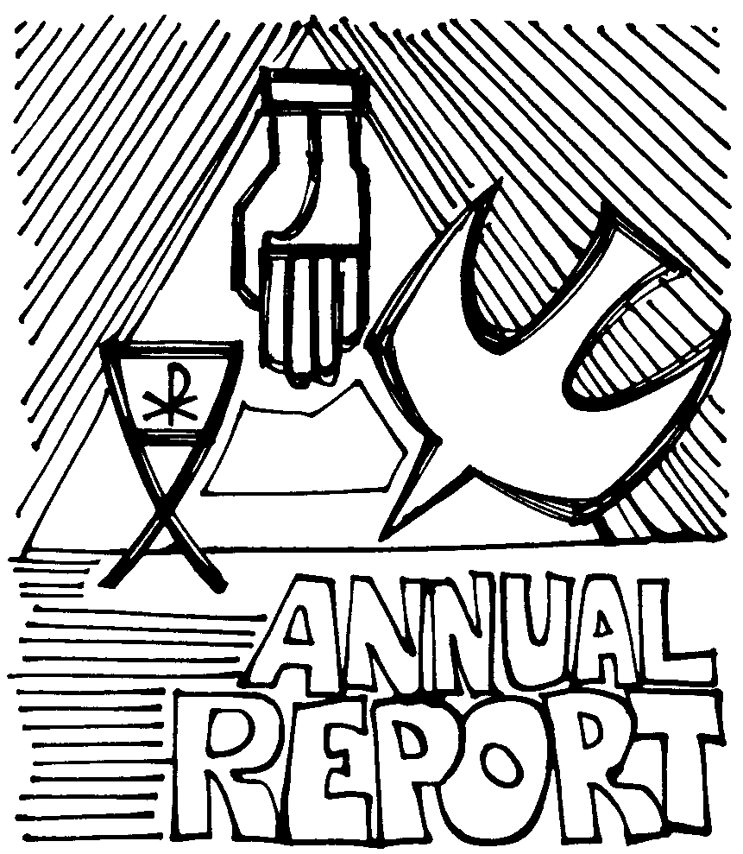
ALL COMMITTEE REPORTS ARE DUE IN THE OFFICE TUESDAY, JANUARY 14, 2020 TO BE INCLUDED IN THE PUBLISHED REPORT FOR THE ANNUAL MEETING ~ PART 2 ON FEBRUARY 9TH.
Reports are need from: the Pastor, the Council President, the Financial Secretary, the annual financial report, and the budget for 2020.
Altar Guild, Fellowship Committee, Outreach Committee, Redeemer Church Women, Worship and Music, and all other ministries that wish to submit an annual report are welcome to do so but also need to be in the office by Tuesday, January 13th. Thank You!!!
ANNUAL MEETING – PART 2
We will be having our Annual Meeting (Part 2) on February 9th after our Worship Service. The Annual Reports will be presented and the delegates for the Annual Synod Assembly will be chosen.
Now might be a time to reflect and pray about your gifts of time, talent and treasure to God through the church. Please pray as we engage in God’s work.


Membership Directory

The first run of our new Membership Directory was given out at the Annual Meeting (Part 1)!! We are updating and making any changes necessary so we can have the final, final directory ready for the Annual Meeting Part 2! Do we have the wrong phone number for you, missed someone, wrong address, think a constant visitor should be included that we don’t have? NOW is the time to let us know! You can pick up your own copy of the directory in the entry way and make any changes on the copy that is there at the same time. You may also call the Office to give any updated information.


Leisure World InterFaith Council
will hold their Annual Gala
On Thursday, January 30, 2020
At: 6:00 p.m.
In: Clubhouse 2
Cost: $25.00

Who do YOU think they are honoring?!??
Come and find out …
(If you guessed the initials Pastor G.M.
you are right!☺)
Choice of Spinach Quiche or Roast Beef
for dinner with sides and dessert.
Entertainment from Sole Suede Dancers

Please purchase your tickets by January 20, 2020
From Pastor Lisa or call the office to make reservations (562) 598-8697


Save the Date

For Pastor Lisa Rotchford’s
Installation!!

Sunday, February 16
At
3:00 p.m.
Come, Welcome,
and Celebrate with Us!


20207



SUNDAY | MONDAY | TUESDAY | WEDNESDAY | THURSDAY | FRIDAY | SATURDAY
 |  |  | 1  11:30 a.m. – Communion and Healing Service with a special New Year’s toast! | 2  NO Office Hours | 3 | 4
5  EPIPHANY OF OUR LORD  10:30 am Holy Communion Service  Coffee Fellowship | 6 | 7  10:00 a.m. to 1:00 p.m. Office Hours | 8  10:30 a.m. – Bible Study  11:30 a.m. – Communion and Healing Service | 9  10:00 a.m. to 1:00 p.m. Office Hours | 10 | 11
12  BAPTISM OF OUR LORD  10:30 am Worship Service  Food Ingathering  Coffee Fellowship | 13 | 14  10:00 a.m. to 1:00 p.m. Office Hours  ANNUAL REPORTS DUE  NEWSLETTER ARTICLES & THOSE WHO SERVE DUE | 15  10:30 a.m. – Bible Study  11:30 a.m. – Communion and Healing Service | 16  10:00 a.m. to 1:00 p.m. Office Hours  10:00 a.m. – SBHRC Devotions | 17 | 18
19  10:30 am Holy Communion Service  Pastor Lynda Elmer Presiding  Coffee Fellowship | 20 | 21  10:00 a.m. to 1:00 p.m. Office Hours  2:30 p.m. – Finance Committee Meeting  NEWSLETTER PRINTED | 22  10:30 a.m. – Bible Study  11:30 a.m. – Communion and Healing Service | 23  10:00 a.m. to 1:00 p.m. Office Hours  2:30 p.m. – Council Meeting  9:30 am to 3:30 pm - Respite Care | 24 | 25
26  10:30 am Worship Service  Mission Moment  Birthdays Celebrated at Coffee Fellowship | 27 | 28  10:00 a.m. to 1:00 p.m. Office Hours  2:00 p.m. –Outreach Visitation  NEWSLETTER MAILED | 29  10:30 a.m. – Bible Study  11:30 a.m. – Communion and Healing Service | 30  10:00 a.m. to 1:00 p.m. Office Hours  6:00 p.m. – Interfaith Gala | 31

