In This Issue …
Redeemer Lutheran Church
of Leisure World
13564 St. Andrews Drive
Seal Beach, California 90740
ADDRESS SERVICE REQUESTED
Article Page
December 2019
Message from the Pastor 1-2
Emergency Pastoral Care 2
President’s Message 3-4
Those Who Serve 5
Birthdays and Anniversaries 6
Sealed Pledges 6
Our Budget and Expenses 7
Offering Envelopes 7
Remember in Prayer 8
Bible Study 9
Holiday Faire 9
Christmas Outreach 9
Advent Devotions and Soup Suppers 10
Christmas Service 10
Calling All Cookie Bakers 11
Annual Reports 11
Annual Meeting Announcement 12
Membership Directory 12
Monthly Calendar Center
Annual Personal Giving Reports 13
Year End Giving 13
New Year’s Day Service 13
Non-profit Org.
U S Postage
PAID
Long Beach, CA
90815
Permit No. 70008
Christmas Blessing 14
Advent Wreath Prayers 15-16
Rose Parade Float 17
Poinsettia Requests 18
Mission Moment 19
Outreach Team 19
Lessons to Study 20
Flowers 21
Worship and Discipleship 22-23
Office Information 24


From Pastor Lisa Rotchford …
Redeemer Lutheran Church
of Leisure World
13564 St. Andrews Drive
Seal Beach, CA 90740
Phone: (562) 598 - 8697
FAX: (562) 598 - 8697
E-mail: redeemer_lutheran@verizon.net
Website: www.redeemerlutheransealbeach.com

“Light in the Darkness”

Dear Family and Friends:

You can tell one’s favorite coffee mugs by how worn they become with frequent use. One of my favorites, lovingly faded with time and use, is inscribed “Live Your Life in Wonder.” Words simply cannot describe the beauty of God’s majesty and sometimes I stand in awe and wonder at it, old coffee mug in hand!

One of these “awe-filled” moment took place while on a visit to Yosemite National Park. Many of you have travelled there or may have seen pictures of the spectacular glacier-made valley — I like to think of it as God’s hand-carved natural cathedral(!). I love visiting Yosemite in any of the four seasons, but it was a cold, dark night in December that provided one of the most heart-warming moments I’ve ever experienced.

I grabbed my trusty mug filled with cocoa, stepped out into the enveloping darkness and looked up at the heavens. While a typical glance at an evening sky shows a black canvass dotted with a few stars, in the darkened Yosemite Valley away from interfering city lights, God’s beautiful galaxy can be seen as the opposite: there were more white stars than black sky. The stars were so bright and so close, that the darkness of the sky truly faded in the background and the lights in the heavens took over one’s vision. Lights from God’s heavens — along with the crisp

Church Office Hours: 10:00 a.m. to 1:00 p.m.
Tuesdays and Thursdays.
Please call and leave a message at all other times.
Sunday Worship: 10:30 a.m. Traditional Service
(Holy Communion on first and third Sundays)
Bible Study: 10:30 a.m. Wednesdays – Conference Room
Holy Communion and Healing Service: 11:30 a.m. Wednesdays – Sanctuary
Advent Devotion and Soup Supper: First Three Wednesdays of December at 3:00 p.m. in the Fellowship Hall
Outreach Visitation: 2:00 p.m. the Last Tuesday of the Month – Conference Room
Council Meeting: 2:30 p.m. the 4th Thursday of the Month – Conference Room (No December Meeting)
Respite Care: 9:30 a.m. to 3:30 p.m.
Monday, Tuesdays and Thursdays
Food Donations: Mickey Costello, Carl and Jessica Keene
Church Staff
Pastor: Rev. Lisa Rotchford
phone is (714) 833-7332
Secretary: Margo Geesing
Organist: Sharon Heck
But all is not sweetness and light in this part. This is where Jesus give the mission of the twelve, the commissioning, and warnings of coming persecutions, and finally give the conditions of discipleship and the rewards of listening to them. The next section deals with the opposition of Jesus’s teachings and behaviors by the powers of Israel. We hear the parables of Jesus and, frequently the explanation of those parables. There are comparisons of “the kingdom of heaven is like …” which underlines the difference of attitudes of his followers and those in power and his rejection by those he has come to save. The fifth section continues with the building of the kingdom and the building of Jesus’s church on Peter. This includes Jesus’s transfiguration, more healings, more predictions of the passion, and more confrontations with the Pharisees.
The sixth section covers Jesus’s ministry in Judea and his road to Jerusalem. This is focused primarily on the costs of discipleship. Jesus gives more parables but they seem to take a darker turn. He sets an either/or tone in these parables. He speaks of the end times and judgement. Both the Sadducees and the Pharisees become more confrontational; asking questions to trip him up. Jesus responds in kind; in some instances, you can just hear the contempt he has for them all.
The last section is the Passion and Resurrection. Note that in the Gospel of Matthew there is no Ascension. The Gospel ends with Jesus commissioning them to go and teach, preach, and baptize (activities we carry on today!). There are some details that I find interesting in this Gospel. There seems to be a little more compassion for Pilate, we meet Simon the Cyrenian, the aftermath of the death of Jesus is a bit more violent with an earthquake and rising bodies, the centurion and his men acknowledge the divinity of Jesus. Also, we hear of Joseph of Arimathea in this version and Jesus only meets the women who have come to properly prepare the body, none of the disciples, at the resurrection who react with adoration; not fear.
So, that’s my brief overview of the Gospel of Matthew. Let’s see how we can delve into it this year in this column, in the sermons on Sundays, in Worship on Wednesdays, and in Bible Studies throughout the year! Come along on the journey, perhaps you will learn something about your relationship with Jesus or perhaps someone will learn something from you through your relationship with Jesus but we always travel in relationship with Jesus!
cold temperature of that December evening — literally took my breath away.

As we…

— proclaim in the Gospel on Christmas morning: “The light shines in the darkness, and the darkness has not overcome it.” - John 1:5;
— light each Advent and Christmas candle that reminds us how the light of Christ breaks the darkness and leads us to eternal life;
— read and hear the familiar story of the angels in heaven singing the glory in a star-filled sky;
— gather round our sanctuary’s brightly lit Christmas tree and share the light of Jesus by joining our voices with those of the angels that brightened the first Christmas morn…

…May we live our lives in wonder and shine the light of Christ into God’s majestic world, as he comes into our life again this Christmas, bringing us light and life now and forevermore.

Pastor Lisa

Emergency Pastoral Care: Whenever you are in need of emergency pastoral care give Pastor Lisa a phone call (714) 833-7332. Jerry Brady and Margo Geesing (our secretary) also know how to reach Pastor Lisa.

Message from Our President …
Dear Members and Friends:
At our November 10 Congregational meeting Nancy Anderson was elected as a new member of Redeemer’s Church Council and Terry Durham, Chris Moore, and myself were re-elected to three-year terms.
Since nobody on the Council will be in a position to take over the Presidency for 2020, I explained to the congregation that I would be willing to run for the office for one more year, however the congregation would have to vote to void one of the by-laws stating a council member can serve only two consecutive terms in the same office. The motion was passed and I sincerely thank you for your confidence in me, with all the glory going to our Lord. I pray for a very successful new year with Pastor Lisa at our helm and this wonderful body of Christians spreading the Gospel and being a beacon of light here in Leisure World. The Church Council will vote on new officers in our January meeting. Traditionally, the Council does not meet in December.
The budget for 2020 was approved by the congregation after being presented by our Financial Chairperson, Kay Pushman. We are so fortunate to
Reflections on WORSHIP and DISCIPLESHIP by Margo Geesing
“The Gospel of Matthew”
This year we will have all four Sundays of Advent celebrated. Since we all know a lot about the “Advent Gospels” I would like to do a brief reminder of the Gospels we are hearing this month followed by a longer overview of the Gospel of Matthew.
The first Gospel lesson is almost at the end of Matthew’s Gospel (chapter 24) where Jesus tells of his second coming and for all of his followers to be awake and busy. The second Sunday of Advent we have a lesson (chapter 3) from John the Baptist calling us to repent and a foreshadowing of Jesus’s coming. The third Sunday of Advent (chapter 11) we continue with a reference to John the Baptist who expected the Messiah to bring God’s judgement but Jesus turned this around by bring healing and forgiveness. For the fourth Sunday of Advent we get Joseph’s perspective on the pregnant wife! We also get two descriptions of the naming of the child: Jesus which means God Saves and Emmanuel which means God is with us. The last week of December we get the gory part of the birth story (chapter 2) with the flight to Egypt, massacre of the infants, and the return from Egypt
Matthew’s Gospel was written for the Jews. His symbol is the lion and his focus is of Christ as King. His Gospel is broken into seven large sections beginning with the infancy narrative. Because of the focus of “Christ as King”, his Gospel begins with the genealogy of Jesus. Through this lineage back to Abraham Matthew presents Jesus as the King of Kings. Between Matthew and Luke, we get the entirety of Jesus’s birth and his childhood, which isn’t much. We also get to know Joseph, briefly, in his care and respect of Mary and his obedience to God, (definitely listen to the Gospel on December 22nd and 29th for this.)
The second part is the Proclamation of the Kingdom where Jesus begins his ministry. If you want short bits of Jesus’s teachings on various subjects this is where you go! This includes the Sermon on the Mount, salt and light, love of enemies, prayer, God and money, and the golden rule.
The third part is the ministry and mission in Galilee. This section has a number of healings and shows the compassion of Jesus.

Altar Flowers for December
December 1st:
Leslie Parker in Honor of Cloven’s Birthday.
December 8th:
Leslie Parker in Memory of My Husband, Baruch.
December 15th:
Pastor Lisa in Loving Memory of My Parents, Charles and Monica Rotchford.
December 22nd:
Poinsettias
December 29th:
Poinsettias

Flower Chart Directions
- There are 2 bouquets for each Sunday.
- Print your name and the special reason for the request on the line next to the date you would like them.
- If there is not enough room to write your request on the chart, please leave the secretary a note in her box specifying your request.
- The requested donation for one bouquet is $15.00; $30.00 for both.

If you wish to request both bouquets, please note that on the chart.
When putting your donation in an envelope, please note that it is for altar flowers and the date of your flowers. Please write a separate check for flowers. Do not include it with your regular offering.
have her talents at our disposal and we thank her for her contributions to our Church.
Spread the word about our Christmas morning Worship Service! It will be a celebration of Christmas hymns and Scripture and, to my knowledge, probably the only Protestant service in Leisure World on that day, so invite your neighbors and friends (especially anyone living alone.) It will be on Wednesday, December 25 at 10:30 a.m. in our Sanctuary. Hope to see you there!
Christ’s Blessings to you,
Jerry Brady
President

P.S. If you are a member who might like to experience a really stimulating spiritual event, why not give some thought to representing Redeemer’s congregation as a delegate to our Synod Assembly on May 28 – 30, 2020? Talk to me or Pastor Lisa about it.
Carol Costello has been appointed to fill the Council term of Dena Anderson who recently resigned. Welcome, Carol and thanks for your service, Dena.



THOSE WHO SERVE
THIS MONTH
Please study the following at home to prepare for Sunday Worship:
Lessons for First Sunday of Advent
through the First Sunday of Christmas

Newsletter Assembly

Sara Gould

Maria Swift

Dee Sessa

Altar Guild

Carol Costello

Alice Dokter

Betty Lucero

Sylvia Makus

Financial Team
1st: Christa Diesslin
Flo Nesland
Alma Zamzow
8th: Wendy Alfageme
Rose Kroll
Alma Zamzow
15th: Wendy Alfageme
Flo Nesland
Alma Zamzow
22nd: Wendy Alfageme
Rose Kroll
Alma Zamzow
29th: Christa Diesslin
Rose Kroll
Alma Zamzow

Acolyte

Barbara Schuyler

Communion Assistant

Jerry Brady

Greeter
Berny Gerard
Reader

Carol Costello

Prayer Leader

Chris Moore

Ushers
Maria Swift
Choir

Beverly Anderson

Dondi Buchrucker

Lynda Elmer

Karen Ford

Debbie Hugdahl

Chris Moore

Kay Pushman

Violet Quist

Shirley Reimers

Join us – there is always space for more voices!
December 1, 2019 – First Sunday of Advent
Isaiah 2:1-5
Psalm 122
Romans 13:11-14
Matthew 24:36-44

December 8, 2019 – Second Sunday of Advent
Isaiah 11:1-10
Psalm 72:1-7, 18-19
Romans 15:4-13
Matthew 3:1-12

December 15, 2019 – Third Sunday of Advent
Isaiah 35:1-10
Psalm 146:5-10
Luke 1:46b-55 (Alternate)
James 5:7-10
Matthew 11:2-11

December 22, 2019 – Fourth Sunday of Advent
Isaiah 7:10-16
Psalm 80:1-7, 17-19
Romans 1:1-7
Matthew 1:18-25
December 24, 2019 – Nativity of Our Lord, Christmas Eve (I)
Isaiah 9:2-7
Psalm 96
Titus 2:11-14
Luke 2:1-20

December 25, 2019 – Nativity of Our Lord, Christmas Day (II)
Isaiah 62:6-12
Psalm 97
Titus 3:4-7
Luke 2:1-20

December 25, 2019 – (III)
Isaiah 52:7-10
Psalm 98
Hebrews 1:1-12
John 1:1-14

December 29, 2019 – First Sunday of Christmas
Isaiah 63:7-9
Psalm 148
Hebrews 2:10-18
Matthew 2:13-23



Global Mission Call ~~
On the last Sunday of each month we take a moment to reflect on our call to serve all of God’s people.
Our next Mission Moment is December 29th.

The Outreach Team meets on the last Tuesday of each month in the Conference Room at 2:00 p.m.


This month we will meet on
December 17th at 2:00 pm!

“Whatever you do for the least of my brothers and sisters, you do for me.”
(Matthew 25:40)

We are Calling All People who like to talk, visit, go out, talk about our church, and be with people: the Outreach Team always has room for new members to join. It is easy work but very necessary. Many hands make light work! Try it, you may find that this is your call from God!


Happy
Birthday

December Birthdays
Nancy Luebben December 6
Sally Hoherd December 10
Joan Cullimore December 11
Jim Pushman December 19
Evelyn Stephens December 28



Sealed Pledges

You should be receiving in the mail this month our annual Sealed Pledge paperwork. If you made a sealed pledge last year that will be returned to you in the same envelope. Please return them in the offertory. They will be dedicated in January and be kept by the altar.


Offering Envelopes are available on the stand in the narthex of the church. Take as many envelopes as you think you may need. Please also remember your pledge. By preparing your envelope ahead of time at home, that way you will not be caught short of your offering and can maintain your pledge. Please put your name on the envelopes that you use. Thank You!
OUR BUDGET AND EXPENSES
Income and Expense Statement
for the Month Ending October 31, 2019
Actual Budget Variance
Operating Income $9,107.41 $10,744.00 ($1,636.59)
Operating Expenses $8,745.18 $10,744.00 $1,998.82
Variance $362.23 $0.00 $362.23
Income and Expense Statement
for the Year to October 31, 2019
Actual Budget Variance
Operating Income $92,831.49 $107,070.00 ($14,238.51)
Operating Expenses $106,217.46 $107,070.00 ($852.54)
Variance ($13,385.97) $0.00 ($13,385.97)
FINANCIAL REPORT AS OF OCTOBER 31, 2019: To sum up October, our expenses for the year 2019 is $128,484.00. To meet these expenses, our offerings have to be about $2,677.00 a week. In October, we received, on average, $2,277.00 a week (this average included a special, one time, gift of $1,000.00), and still we have an average shortage of $400.00 a week. Please, prayerfully consider your giving! Kay Pushman
This is a spreadsheet of our electrical expense to give you an idea of one of the items your weekly donations pay for. Thanking you always for your generosity. Kay Pushman
YEAR 2016 2017 2018 2019
Jan $2,054.00 $1,462.00 $1,470.00 $1,502.00
Feb $2,223.00 $1,718.00 $1,646.00 $2,336.00
March $2,139.00 $2,358.00 $1,633.00 $2,340.00
April $1,246.00 $1,294.00 $1,453.00 $1,152.00
May $528.00 $693.00 $700.00 $999.00
June $545.00 $589.00 $582.00 $1,030.00
July $990.00 $860.00 $766.00 $1,118.00
Aug $729.00 $688.00 $1,159.00 $546.00
Sept $768.00 $876.00 $672.00 $547.00
Oct $686.00 $728.00 $450.00 $518.00
Nov $534.00 $562.00 $586.00
Dec $802.00 $709.00 $1,315.00
Total $13,244.00 $12,537.00 $12,432.00 $12,088.00

Requests for Poinsettias
to decorate the Sanctuary for Christmas

Again, this year, you are invited to dedicate a potted poinsettia in memory of or in honor of a loved one.
The cost of 1 pot is $10.00.
Please fill out the slip and return it with a check for the number of pots you are requesting to the church office by Sunday, December 15th.
The poinsettias will decorate the altar December 22nd through January 5th.
Your Name ________________________________________________

Your Phone Number:

_____________ Number of pots at $10.00 each
In Honor of ________________________________________________

________________________________________________

________________________________________________
or
In Memory of ________________________________________________

________________________________________________

________________________________________________
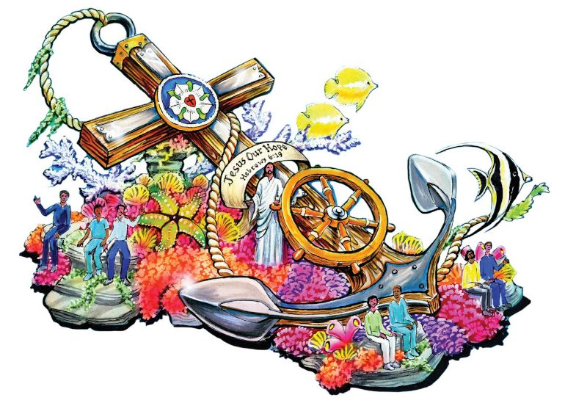
Rose Parade Float
January 1, 2020 marks the 70th year The Lutheran Hour Ministries Float Committee (LHMFC) has sponsored a Christian-themed float in the Rose Bowl Parade! The LHMFC is an all-volunteer group that coordinates the 4,000 volunteer PetalPushers who will decorate the Lutheran float this year, along with as many as ten additional floats.
Pastor Lisa and her hardworking daughter Collette have worked on the Lutheran Float for the last 12 years, and invite anyone who would like to clip dried flowers, glue fruit and seeds, and be a part of this fun and beautiful effort to come along! You can sign up for either 1, 2 or 3 days choosing between 12/26, 12/27 and 12/29 — leaving Leisure World around 2:15 p.m., carpooling/riding in van to Phoenix Decorators in Irwindale, volunteering on the float, and returning to LW at approximately 10:30 pm. (A full shift, but watch out — its addicting!)
There are many jobs that simply require sitting — many long-time volunteers are in wheelchairs and otherwise abled. If you desire, you can stand and work on a float as well. For more detailed information, please see the information sheet available in the narthex. Any questions, you can ask (and sign up!) with Pastor Lisa anytime.
Guidelines for prayer list:
We are requesting all members (and friends) to please call the church office and leave a message requesting prayer regarding any illnesses, surgeries, procedures, and treatments regarding you, church members, and family members. Please also notify us when the prayers are no longer needed. Our pastor is also available after Sunday morning service for personal prayer. Let her know as you leave services and she will meet you at the altar rail immediately following “the last person out of church”.
REMEMBER IN PRAYER
Our Members: Jean Ackerman, Dena Anderson, Evelyn Benedix, Dondi Buchrucker, Joan and Russ Cullimore, Beverly Dinning, Patti Drumm, Barbara Dykman, Bob and Helyn Edwards, Lucy Fitch, Sarah Gould, Barbara LaBoyteaux, Ken Lancaster, Nancy Luebben, Karen Merkel, Dorothea Moll, Chris and Lavona Moore, Kathleen Nilsson, Erich Obersteiner, Ronnie Powell, Jim Pushman, Jann Schaffer, Barbara Schuyler, Anita Smart, Pam Smithson, Nelda Sunday, Linda Tracey, Joan Volden, Bruce Young, Alma Zamzow, and Martha Ziegler;
And Our Family Members and Friends: Lupe, Stephen, Constance (from Rehab), Jesus and Cindy, Tammy Anderson, Laura Arnold, Sally Blevins, Caren Condon, Reigee De Leon, David Dokter, Anna Dow, Michele Dow, Maggie Fitzpatrick, Loretta Gilbert, Julie Guzman, Steve and Jackie Gwaltiney, Dolores and Gordy Jagusch, Joey Jananian, Mary Lanza, Ryan Lloyd, Mary Fran Luebben-Morgan, Betty Mackner, Jessica Mackner, Nancy Maggio, Li-Ann Mankin, Ethan Millerick, Heide Mitchell, Bill Montague, Lisa and Stephan Nicholson, Ariel Perea, Teresa Rodriguez, Collette Rotchford-Golden, Matthew Shaffer, Jack Soyster, Garette Townson, Margaret Unique, Donald Volden, Louise Wagner, Penny Watkins, Nicole Young McNall, and Bryce Young.
We also remember those confined at home, in hospitals, or in nursing homes. And, always pray for peace.

BIBLE STUDY ~ Pastor Lynda
The Bible Study with Pastor Lynda meets Wednesdays from 10:30 a.m. to 11:30 a.m. They are studying the Book of Proverbs. Join us in the conference room. Bibles are available to borrow. Come and bring a friend!

Holiday Faire

Our annual Christmas Craft and “Granny’s Attic” Boutique is scheduled for the first week of December, Wednesday December 4th from 9 a.m. to 3 p.m.
All members are invited to participate with their creations. You may sell or just display. Please call the office to sign-up for a table! Get a jump start on your holiday shopping!

CHRISTMAS OUTREACH
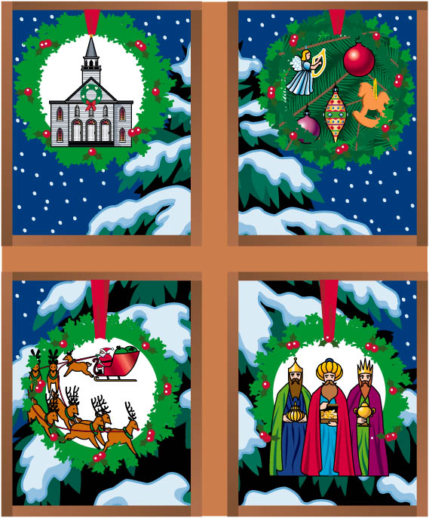
This year, rather than doing the Shoebox Outreach, we as a Church are planning to adopt families from Lutheran Social Service for Christmas! The goal is to provide presents to all members of a family in need. We are going to start collecting financial donations OR, on our Christmas tree, we will include ornaments that have requested gifts for our families. You may choose to take an ornament and purchase the requested gift. We have a due date on December 12 for the gifts to be turned in back under our tree so that they can be gathered and given to the families in time for them to celebrate our Lord’s Birthday.

Third Week of Advent

Use this blessing when lighting three candles.
Blessed are you, God of might and majesty, for you promise to make the desert rejoice and blossom, to watch over the strangers, and to set the prisoners free.

As we light these candles, satisfy our hunger with your good gifts, open our eyes to the great things you have done for us, and fill us with patience until the coming of the Lord Jesus.

O ransomed people of the Lord, come, let us travel on God's holy way and enter into Zion with singing. Amen.

Fourth Week of Advent
Use this blessing when lighting all four candles.

Blessed are you, God of hosts, for you promised to send a son, Emmanuel, who brought your presence among us; and you promise through your Son Jesus to save us from our sin.

As we light these candles, turn again to us in mercy; strengthen our faith in the word spoken by your prophets; restore us and give us life that we may be saved.

O house of David, come, let us rejoice, for the Son of God, Emmanuel, comes to be with us. Amen.

CHRISTMAS DAY through EPIPHANY OF OUR LORD
Use this blessing when lighting the Christ candle.

We give you thanks, God our Father, through Jesus Christ, your beloved Son, whom you sent in this end of the ages to save and redeem us and to proclaim to us your will.

As we light these candles, Lord God, may your Word become flesh through our lives so that we may see him in the fullness of his glory.

THE ADVENT WREATH
One of the best-known customs for the season is the Advent wreath. The wreath and winter candle-lighting in the midst of growing darkness strengthen some of the Advent images found in the Bible. The unbroken circle of greens is clearly an image of everlasting life, a victory wreath, the crown of Christ, or the wheel of time itself. Christians use the wreath as a sign that Christ reaches into our time to lead us to the light of everlasting life. The four candles mark the progress of the four weeks of Advent and the growth of light. Sometimes the wreath is embellished with natural dried flowers or fruit. Its evergreen branches lead the household and the congregation to the evergreen Christmas tree. In many homes, the family gathers for prayers around the wreath.

First Week of Advent
Use this blessing when lighting the first candle.

Blessed are you, God of Jacob, for you promise to transform weapons of war into implements of planting and harvest and to teach us your way of peace; you promise that our night of sin is far gone and that your day of salvation is dawning.
As we light the first candle on this wreath, wake us from our sleep, wrap us in your light, empower us to live honorably, and guide us along your path of peace.
O house of Jacob, come, let us walk in the light of the Lord. Amen.

Second Week of Advent
Use this blessing when lighting the first two candles.

Blessed are you, God of hope, for you promise to bring forth a shoot from the stump of Jesse who will bring justice to the poor, who will deliver the needy and crush the oppressor, who will stand as a signal of hope for all people.
As we light these candles, turn our wills to bear the fruit of repentance, transform our hearts to live in justice and harmony with one another, and fix our eyes on the root of Jesse, Jesus Christ, the hope of all nations.
O people of hope, come, let us rejoice in the faithfulness of the Lord. Amen.
Advent Begins

Advent defined by the dictionary: the anticipation and arrival of a thing, event or person. Advent defined by Redeemer: opportunities to worship, explore and anticipate the arrival of Christ our Lord in the Advent and Christmas year of our Lord 2019, and looking forward to His presence in the 3rd decade of the millennium.
We will have four full Sundays of Advent (Dec. 1, 8, 15 & 22) to anticipate and await the celebratory arrival of Jesus on Christmas. In addition to our Sunday worship services, we will have a chance to more deeply explore Advent and Christmas in our Wednesday Advent/Soup Supper Program from 3-5 pm on Dec. 4th, 11th, and 18th. All of this is in anticipation of a joyous celebration of Christmas at 10:30 a.m. on Wednesday, December 25th! Mark your calendars now and come join your Redeemer family for a rich Advent and Christmas season.


Christmas Service
Bring your friends, family and neighbors to Redeemer’s Christmas Service on the Lord’s Birthday, December 25th at our “regular” worship time: 10:30 a.m. Traditional Carols & Scripture Lessons will celebrate and honor the day! (And we’ll celebrate with birthday cake in His honor on our regular, last Sunday of the month with our other December birthdays on December 29th.) We will have a brunch following the Service (complete with free door prizes!). We will also have a special Communion in the New Year on Wednesday, January 1st at our regular Wednesday mid-week service at 11:30a.m.
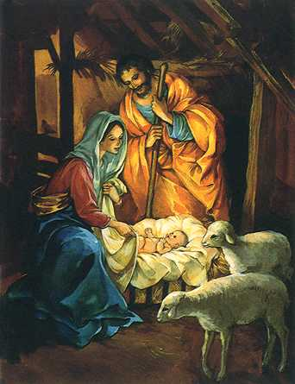
Calling All Cookie Bakers!

Did you know the making and sharing of Christmas cookies dates back to the middle ages? It’s an old Outreach method we’re going to try in 2019!
This year we are ALL a part of the Outreach Team’s efforts to share the “sweetness of Redeemer” through our annual Cookie delivery! This year, if you are willing and able to contribute a few homemade cookies on December 15th, we will be packaging a variety of them in holiday bags to keep them fresh and then send them out to neighbors who might just like to have a little taste of Redeemer. All of our homebound parishioners will receive them, but on December 22nd we all will be asked to distribute a bag or two to a neighbor who might just like a little something sweet and a written invitation to attend our special Christmas service on Wednesday, December 25th — the actual date celebrated as Jesus birthday! (We’ll also include our regular worship schedule if they’d like to come on a Sunday as well:)
Spread the sweet love found at Redeemer through sweet treats…Jesus just might appreciate being remembered at a sweet birthday party! :)

ANNUAL REPORTS
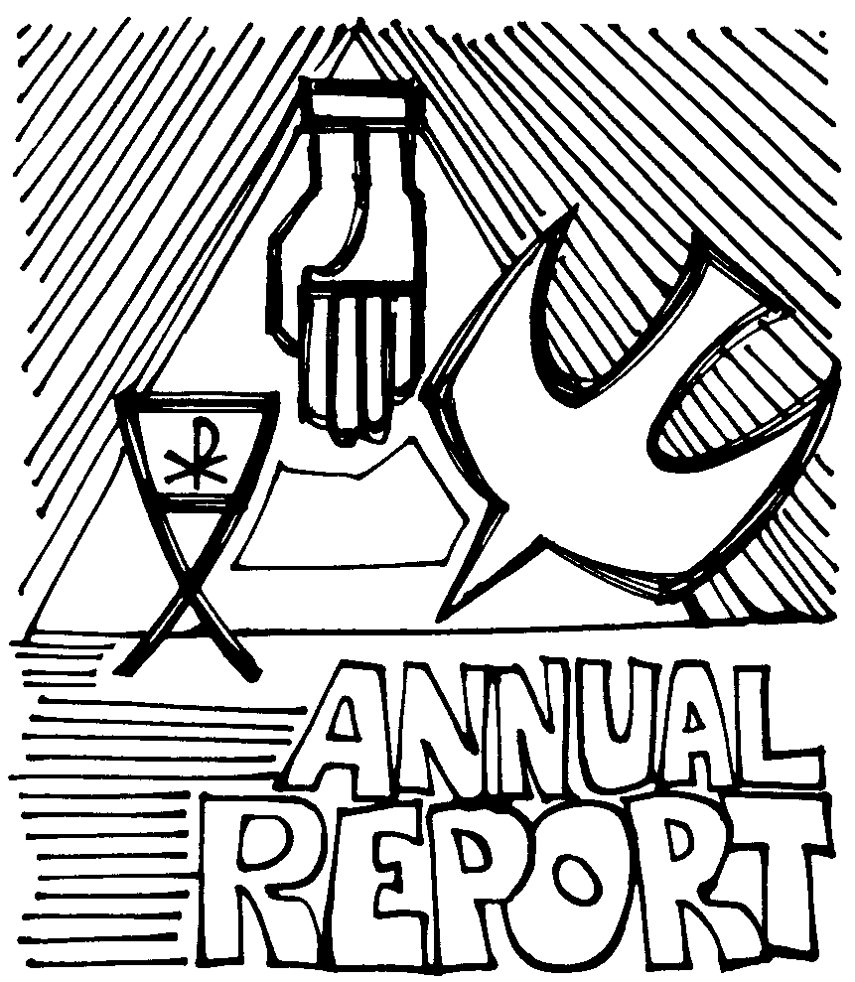
ALL COMMITTEE REPORTS ARE DUE IN THE OFFICE TUESDAY, JANUARY 13, 2020 TO BE INCLUDED IN THE PUBLISHED REPORT FOR THE ANNUAL MEETING ~ PART 2 ON FEBRUARY 9TH.
Reports are need from: the Pastor, the Council President, the Financial Secretary, the annual financial report, and the budget for 2020.
Altar Guild, Fellowship Committee, Outreach Committee, Redeemer Church Women, Worship and Music, and all other ministries that wish to submit an annual report are welcome to do so but also need to be in the office by Tuesday, January 13th. Thank You!!!

Please join us on Christmas Day, December 25, at 10:30 a.m. to celebrate Jesus’s Birthday on the actual date celebrated as Jesus Birthday!
It’s the ONLY Christmas Day Protestant Service in Leisure World!! Bring Friends, Family, Neighbors to this special Birthday Party. We will have a light brunch — quiche, sausages, fruit and cookies following the Service (complete with free door prizes!).
May the Joy and Blessings of the Christmas Season be with you now and throughout the New Year!
Personal Annual Giving Reports

If you wish to have a report of your giving for 2019, please contact the office at (562) 598-8697 and it will be sent to you at the end of January.

Year End Gifts

Year End Gifts are encouraged by many charities at this time of the year. Please remember Redeemer with year-end gifts too. Please pray about a year end gift to your church ~ if you don’t, who will?

New Year’s Day Worship Service

What better way to celebrate the New Year than by welcoming it with our mid-week service at 11:30 a.m. on January 1st, 2020?! Come join us for Worship and Communion and stay for a toast with Martinelli’s as we go out into the New Year — the third decade of the “new” century, to love and serve the Lord!
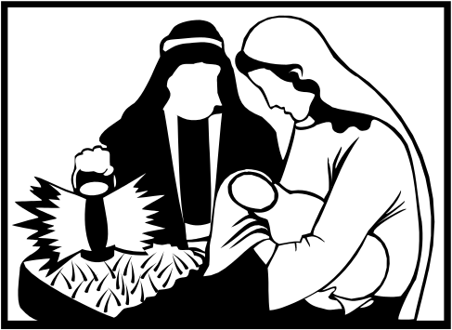
ANNUAL MEETING – PART 2

We will be having our Annual Meeting (Part 2) on February 9th after our Worship Service. The Annual Reports will be presented and the delegates for the Annual Synod Assembly will be chosen.
Now might be a time to reflect and pray about your gifts of time, talent and treasure to God through the church. Please pray as we engage in God’s work.

Membership Directory

The first run of our new Membership Directory was given out at the Annual Meeting (Part 1)!! We are updating and making any changes necessary so we can have the final, final directory ready for the Annual Meeting Part 2! Do we have the wrong phone number for you, missed someone, wrong address, think a constant visitor should be included that we don’t have? NOW is the time to let us know! You can pick up your own copy of the directory in the entry way and make any changes on the copy that is there at the same time. You may also call the Office to give any updated information.


20197


SUNDAY | MONDAY | TUESDAY | WEDNESDAY | THURSDAY | FRIDAY | SATURDAY
1  1ST SUNDAY OF ADVENT  10:30 am Holy Communion Service  Coffee Fellowship  Adopt a Family Christmas Ornaments | 2  9:30 am to 3:30 pm - Respite Care | 3  10:00 a.m. to 1:00 p.m. Office Hours  9:30 am to 3:30 pm - Respite Care  NEWSLETTER ARTICLES & THOSE WHO SERVE DUE | 4  10:00 a.m. to 3:00 p.m. – Holiday Bazaar  10:30 a.m. – Bible Study  11:30 a.m. – Communion and Healing Service  3:00 p.m. – Advent Devotions and Soup Supper | 5  10:00 a.m. to 1:00 p.m. Office Hours  9:30 am to 3:30 pm - Respite Care | 6 | 7
8  2ND SUNDAY OF ADVENT  10:30 am Worship Service  Jerry Brady Preaching  Food Ingathering  Coffee Fellowship  Adopt a Family Christmas Ornaments | 9  9:30 am to 3:30 pm - Respite Care | 10  10:00 a.m. to 1:00 p.m. Office Hours  9:30 am to 3:30 pm - Respite Care  NEWSLETTER PRINTED | 11  10:30 a.m. – Bible Study  11:30 a.m. – Communion and Healing Service  3:00 p.m. – Advent Devotions and Soup Supper | 12  10:00 a.m. to 1:00 p.m. Office Hours  10:00 a.m. – New Member Orientation  9:30 am to 3:30 pm - Respite Care  10:00 a.m. – SBHRC Devotions  Adopt a Family Christmas Gifts Due | 13 | 14
15  3RD SUNDAY OF ADVENT  10:30 am Holy Communion Service  Coffee Fellowship  Cookies Needed | 16  9:30 am to 3:30 pm - Respite Care | 17  10:00 a.m. to 1:00 p.m. Office Hours  2:00 p.m. –Outreach Visitation  9:30 am to 3:30 pm - Respite Care  NEWSLETTER MAILED | 18  10:30 a.m. – Bible Study  11:30 a.m. – Communion and Healing Service  3:00 p.m. – Advent Devotions and Soup Supper | 19  10:00 a.m. to 1:00 p.m. Office Hours  9:30 am to 3:30 pm - Respite Care | 20 | 21
22  4TH SUNDAY OF ADVENT  10:30 am Worship Service  Coffee Fellowship  Cookies Distributed | 23  9:30 am to 3:30 pm - Respite Care  SECRETARY ON VACATION | 24  CHRISTMAS EVE  NO Office Hours  NO Respite Care | 25  CHRISTMAS DAY  10:30 a.m. – Lessons and Carols Service  Followed by Brunch and free door prizes | 26  NO Office Hours  9:30 am to 3:30 pm - Respite Care  PetalPushers 2:15 p.m. to 10:30 pm. | 27  PetalPushers 2:15 p.m. to 10:30 pm. | 28
29  10:30 am Worship Service  Karen Merkel Preaching  Mission Moment  Birthdays Celebrated at Coffee Fellowship  PetalPushers 2:15 p.m. to 10:30 pm. | 30  9:30 am to 3:30 pm - Respite Care | 31  10:00 a.m. to 1:00 p.m. Office Hours  9:30 am to 3:30 pm - Respite Care | JANUARY 1  NEW YEAR’S DAY  11:30 a.m. – Communion and Healing Service

