To get the smile.amazon.com app on an iphone:
On your Home screen, go to the App Store
At the bottom right of the screen, go to the
magnifying glass (search button), click on it
smile.amazon.com
in the search bar type in: smile.amazon.com
Click on the Smile.Amazon button

Allow it to download to your phone!
App Store Button
If at any point you get lost or cannot find something, please either see Kay Pushman (especially for the iphone) or come by the office and see us and we will help you through it!
Smile.Amazon button
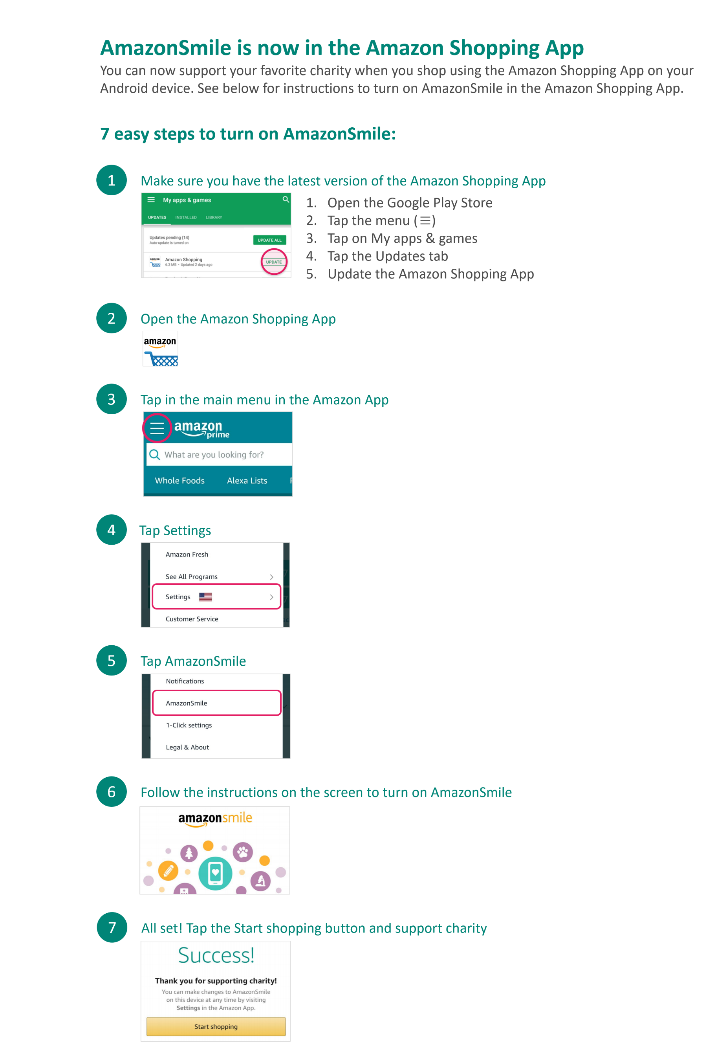
If at any point you get lost or cannot find something, please either see Kay Pushman (especially for the iphone) or come by the office and see us and we will help you through it!

