Redeemer Lutheran Church of Leisure World and
St. Theodore of Canterbury Episcopal Church
13564 St. Andrews Drive
Seal Beach, CA 90740
(562) 598-8697
e-mail: redeemer_lutheran@verizon.net
website: www.redeemerlutheransealbeach.com
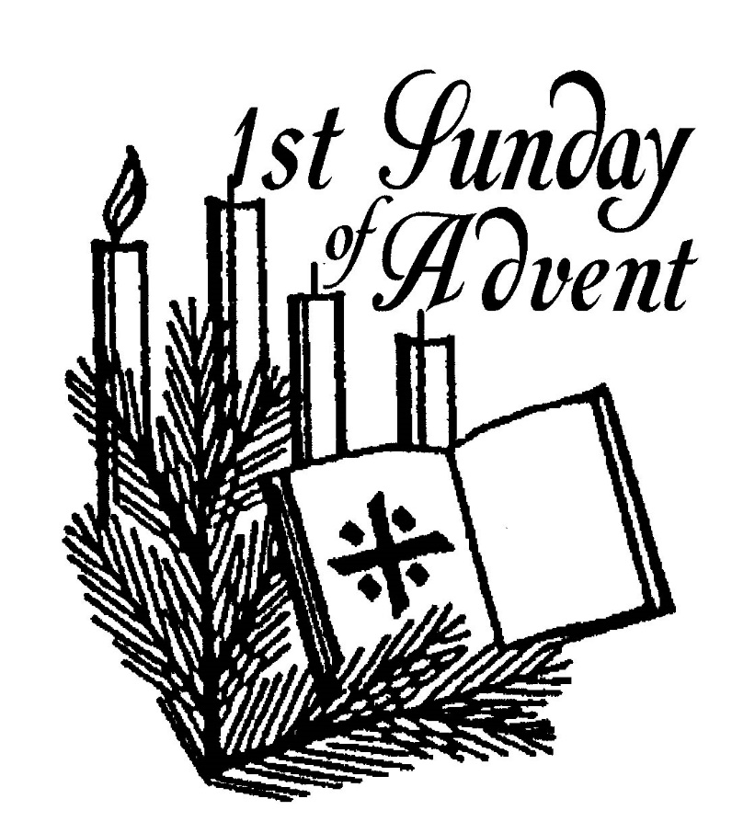

Holy Communion Service
First Sunday of Advent
November 30, 2025

PRELUDE played by organist

WELCOME AND ANNOUNCEMENTS

CHOIR INTROIT

OPENING HYMN WOV [Blue Book] # 627
“My Lord, What a Morning”

INVOCATION
P In the name of the Father, the Son, + and the Holy Spirit.
C Amen.

GREETING
P Grace and peace from God our Father and the Lord Jesus Christ, and the promised gifts of the Holy Spirit, be with you all.
C And also with you.

CONFESSION AND FORGIVENESS
P Blessed be the Holy Trinity, ☩ one God, whose home is heaven and earth, whose salvation is sure.
C Amen.
P Let us confess our sin in the presence of God and of one another.
Silence is kept for reflection.
C Long-expected God, we confess that we look to ourselves for the peace and security only you can provide. We reach for swords and spears, reluctant to release our grip on the ways of war. We become impatient while waiting, and weary of keeping awake. Free us from self-reliance, and teach us to live in harmony with our neighbors. Increase our trust in God’s timing, and awaken us to your advent among us, that we may abound in the hope you have promised. Amen.
P God judges us not as we deserve, but according to God’s own righteousness. In Christ ☩ we are freed and forgiven, saved by his grace. He is our Savior and Redeemer.
C Amen.

Prayer of the Day
C Stir up your power, Lord Christ, and come to be among us. By your merciful protection save us from the threatening dangers of our sins, and enlighten our walk in the way of your salvation, for you live and reign with the Father and the Holy Spirit, one God, now and forever. Amen.

BLESSING OF THE ADVENT WREATH
Congregation sings verse 1
“Light One Candle to Watch for Messiah”

FIRST SUNDAY OF ADVENT
P Praise to you, O God, our salvation who is near. You hold us in our waiting and keep us awake to the world. You show up in our lives at unexpected times. Bless us as we light this candle to keep vigil for your arrival. We trust that even though we do not know the day or the hour, you hurry to gather all people to your peace.
C Amen.

Light the first candle.

Congregation sings verse 1 (again)
“Light One Candle to Watch for Messiah”

WE HEAR GOD’S HOLY WORD PROCLAIMED

Introduction
The new church year begins with a wake-up call: Christ is coming soon! In today’s readings both Paul and Jesus challenge us to wake from sleep, for we know neither the day nor hour of the Lord’s coming. Isaiah proclaims the day when God will gather all people on the holy mountain and there will be no more war or suffering. Though we vigilantly watch for the promised day of salvation, we wait for what we already have: Christ comes among us this day as the word and meal that strengthens our faith in the promises of God.

The First Lesson is from Isaiah chapter 2 verses 1-5
The visionary message presented in this reading focuses on a future day when God establishes a universal reign of peace. Divine decisions will make war obsolete, and the worshiping community responds: “Let us walk in the light of that Lord now!”

¹ The word that Isaiah son of Amoz saw concerning Judah and Jerusalem.
² In days to come
the mountain of the Lord’s house
shall be established as the highest of the mountains
and shall be raised above the hills;
all the nations shall stream to it.
³ Many peoples shall come and say,
“Come, let us go up to the mountain of the Lord,
to the house of the God of Jacob,
that he may teach us his ways
and that we may walk in his paths.”
For out of Zion shall go forth instruction
and the word of the Lord from Jerusalem.
⁴ He shall judge between the nations
and shall arbitrate for many peoples;
they shall beat their swords into plowshares
and their spears into pruning hooks;
nation shall not lift up sword against nation;
neither shall they learn war any more.
⁵ O house of Jacob,
come, let us walk
in the light of the Lord!

The Word of the Lord.
C Thanks be to God.

PSALM: Psalm 122
I was glad when they said to me, “Let us go to the house of the Lord.” (Ps. 122:1)

¹ I was glad when they said to me,
“Let us go to the house of the Lord.”
² Now our feet are standing
within your gates, O Jerusalem.
³ Jerusalem is built as a city
that is at unity with itself;
⁴ to which the tribes go up, the tribes of the Lord,
the assembly of Israel, to praise the name of the Lord.
⁵ For there are the thrones of judgment,
the thrones of the house of David.
⁶ Pray for the peace of Jerusalem:
“May they pros- per who love you.
⁷ Peace be with- in your walls
and quietness with- in your towers.
⁸ For the sake of my kindred and companions,
I pray for your prosperity.
⁹ Because of the house of the Lord our God,
I will seek to do you good.”

The Second Lesson is from Romans chapter 13 verses 11–14
Paul compares the advent of Christ to the coming of dawn. We live our lives today in light of Christ’s coming in the future.

¹¹ Besides this, you know what time it is, how it is already the moment for you to wake from sleep. For salvation is nearer to us now than when we became believers; ¹² the night is far gone; the day is near. Let us then throw off the works of darkness and put on the armor of light; ¹³ let us walk decently as in the day, not in reveling and drunkenness, not in illicit sex and licentiousness, not in quarreling and jealousy. ¹⁴ Instead, put on the Lord Jesus Christ, and make no provision for the flesh, to gratify its desires.

The Word of the Lord.
C Thanks be to God

GOSPEL ACCLAMATION:
(Congregation stands and sings “Open Our Eyes” following the Second Lesson.)

The Gospel Lesson from Matthew chapter 24 verses 36–44
Jesus describes his second coming as a sudden, turbulent event that will bring about deep change to our normal, day-to-day lives. Therefore, he urges people to stay awake, be aware, and wait expectantly, because the Son of Man will come unannounced.

Jesus said to the disciples, ³⁶ “About that day and hour no one knows, neither the angels of heaven, nor the Son, but only the Father. ³⁷ For as the days of Noah were, so will be the coming of the Son of Man. ³⁸ For as in the days before the flood they were eating and drinking, marrying and giving in marriage, until the day Noah entered the ark, ³⁹ and they knew nothing until the flood came and swept them all away, so, too, will be the coming of the Son of Man. ⁴⁰ Then two will be in the field; one will be taken, and one will be left. ⁴¹ Two women will be grinding meal together; one will be taken, and one will be left. ⁴² Keep awake, therefore, for you do not know on what day your Lord is coming. ⁴³ But understand this: if the owner of the house had known in what part of the night the thief was coming, he would have stayed awake and would not have let his house be broken into. ⁴⁴ Therefore you also must be ready, for the Son of Man is coming at an hour you do not expect.”

A Reading from the Gospel according to Matthew.
C Praise to you, O Christ

SERMON The Rev. Murray D. Finck, Bishop Emeritus
“Awake! and Ready to Go!”

CHOIR ANTHEM “Stay Awake, Be Ready”

THE NICENE CREED
C We believe in one God, the Father, the Almighty, maker of heaven and earth, of all that is, seen and unseen.
We believe in one Lord, Jesus Christ, the only Son of God, eternally begotten of the Father, God from God, Light from Light, true God from true God, begotten, not made, of one Being with the Father. Through him all things were made.
For us and for our salvation he came down from heaven; by the power of the Holy Spirit he became incarnate from the virgin Mary, and was made man.
For our sake he was crucified under Pontius Pilate; he suffered death and was buried. On the third day he rose again in accordance with the Scriptures; he ascended into heaven and is seated at the right hand of the Father. He will come again in glory to judge the living and the dead, and his kingdom will have no end.
We believe in the Holy Spirit, the Lord, the giver of life, who proceeds from the Father and the Son. With the Father and the Son he is worshiped and glorified. He has spoken through the prophets.
We believe in one holy catholic and apostolic Church. We acknowledge one Baptism for the forgiveness of sins. We look for the resurrection of the dead, and the life of the world to come. Amen.

*the word “catholic” in the creed means “universal.” It is the original word used as this profession of faith was adopted by the early Christian Church.

Prayers of THE PEOPLE
L … God of grace,
C hear our prayer.

OFFERTORY “O Day of Peace”

Offering Prayer

P Nourishing God, you are water in the wilderness and streams in the desert. Through this meal, satisfy our hunger and thirst for your love and grace, that we may rejoice and be for the world signs of your kingdom come.
C Amen.

THE GREAT THANKSGIVING

THE LORD’S PRAYER LBW [Green Book] Page 71

Invitation to Communion

P Here is life. God is with us. Come, receive what God has promised. This is the Table of the Lord. All is ready and everyone is always welcome.
Holy Communion Distribution (The Congregation is invited to come forward to receive Holy Communion or a blessing. If you are unable to come to the altar, Holy Communion will be brought to you in the pew. We believe Christ is truly present in, with, and under the bread and wine/juice. Those who are baptized and share that belief are always welcome at this table. Please speak to the Pastor if you have any questions. The inside circle of glasses contains white non-alcoholic grape juice.)

Prayer of Thanksgiving
C God our host, at this table you have fed us with joy and gladness. Send us forth, eager to share the feast, welcome the stranger, and bear good fruit in the name of Jesus. Amen.

Blessing
P May God who comes among us, Father, ☩ Son, and Holy Spirit, grant us patience in our waiting, peace in the darknesses around us, and good news to share today and always.
C Amen.

CLOSING HYMN LBW [Green Book] # 22
“The Advent of Our God”

Dismissal
P Go in peace. Let us always keep awake.
C Thanks be to God.

POSTLUDE played by organist

Music reprinted with Permission under One License #A-709179
Reprinted from Words for Worship, copyright 2023 Augsburg Fortress. Used by permission. Scripture quotations (except psalms) from the New Revised Standard Version Bible, copyright 1989 Division of Christian Education of the National Council of Churches of Christ in the USA. All rights reserved. Used by permission.

Interim Pastor: The Rev. Murray D. Finck, Bishop Emeritus
Organist and Choir Director: Sharon Heck
Flowers are given by: No Requests

THOSE WHO SERVE TODAY
Presider: The Rev. Murray D. Finck, Bishop Emeritus
Organist: Sharon Heck
Holy Communion Assistant Linda Peters
Acolyte Shirlene Bradrick
Reader Kay Pushman
Prayer Leader Carol Costello
Financial Team Wendy Alfageme and Kay Pushman

THIS WEEK
TODAY: Fellowship in the Fellowship Hall
Birthdays Celebrated at Fellowship
Wednesday: 3:00 p.m. Advent Gathering and Supper
Next Sunday: 10:30 a.m. Holy Communion Service
Second Sunday of Advent

Redeemer Finance: Monthly Offering through November 23
Budgeted Monthly Expense $8,250.00
Offering $4,033.50
Needed for Budget $4,216.50

CHURCH COUNCIL
President: Kay Pushman, Vice President: Wendy Alfageme, Secretary: Nancy Anderson, Treasurer: Doris Weinert
Members at Large: Susan Avila, Carol Costello, Sandy Langdale, Carmen Leslie, Betty Lucero, Sylvia Makus, Linda Peters and Michael Vanvales

REMEMBER IN PRAYER
Barry, Jean, Kathy, Wendy, Beverly, Nancy, Evelyn, Shirlene, Carol, Mickey, Evelyn, Gloria, Christa, Alice, Barbara, Cedric, Lucy, Karen, Kelly, Raymond, Marilyn, Brian, Carl, Jessica, Carol, Rose, Sandra, Elaine, Barbara, Betty, Nancy, Phyllis, Sylvia, Flo, Eileen, Erich, Leslie, Linda, Ronnie, Kay, Violet, Linda, Ron, Collette, Lisa, Patty, Barbara, Joan, Susan, Kathy, Juanita, Clarence, Debbie, Joan, Doris, Linda, Bruce, Alma, Martha, Marianne, Robert, Laura, Jim, Loretta, Ray, Patty, Delrie, Bill, Betty, Lorna, M. Teresa, Joan, Mike, Frankie, Donna, Ernie, Eileen, Darleen, Sharon, Danuta, Lynne, Ethan, Kurt, Brinly, McCall, Kathy, Nayleen, Nicole, Donald, Maria, Andy, Owen, Tom, Anastasia, Claire, Fran, Chris, Kyle, Michele, Wes, Sam, Kolt, Brigid, Joanna, Dale, Tom, Rosalia, Elaine, Rachel, Mike, Jesus, Richard, Kelsey, Margaret, Steven, Dian, EK Song, Linda, Ronni, Hiroko, Sibonay, Keith, Wendy, Carmen, Pyongyang, Leslie, Ann, Scott, George, Margie Sung-ho Kim, John, Jann and Laurie. Please contact the church to add people to the prayer list.

Please pray for those affected by disastrous floods, hurricanes, and wildfires, and pray for the first responders during these devastating calamities.

Please pray for our Presiding Bishop, Yahiel, and local Bishop, David Nagler of the ELCA, and our Presiding Bishop, Sean, and local Bishop John of the ECUSA. We also pray for the victims of the Ukrainian/Russian, Israel/Hamas conflicts, the civil strife in Africa, and the victims and families of all violence and natural disasters.

Gracious God, none who trust in your Son can be separated from your love. Give to those who live alone peace and contentment in their solitude, hope and fulfillment in their love of you, and joy and companionship in their relations with others; through Jesus Christ our Lord. Amen.

Announcements
- Welcome to everyone this morning, and especially to our guests and visitors. Please join us after the Service for Fellowship in the Fellowship Hall when our November Birthdays for Doris Weinert, Barry Thomsen, Christina Paek, Cathy Boufford, Ernie Dinkel, Gloria Curry, Jessica Keene, Lorna Miller-Kaplan, and Mike Vanvales will be celebrated.
- Please take a moment and fill out the attendance slip found in the rack in the pews. Please place it in the offertory plate. Visitors, especially, are invited to fill out a card found in the pew rack and place it in the offering plate. Thank you!
- We wanted to remind everyone that we are continuously collecting food donations of canned and boxed foods for the hungry. Thank you to all those who have brought in food over the last few weeks. This food is donated to Lutheran Social Services in Orange County to help our wider community.
- We ask you to listen carefully to the names read during the Prayers of the People (bolded in the prayer list) and read over the Prayer List in the bulletin. Please let us know when we can remove them. The prayer list is meant for additional prayers when someone is going through a special need for more prayer. Examples: surgeries, cancer, heart concerns, falls, broken bones, hospital stays, accidents, hospice, and such immediate conditions in need of extra prayers.
- We will be gathering on Wednesdays: December 3rd, 10th, and 17th, at 3:00 p.m. for an Advent program, followed by a meal together at 4:00 p.m.
- The Bible Study has ended its study of the Women in the Bible. We will not be meeting again until the new year.
- Forms for the Memorial Cross Wall are on the table in the back of the sanctuary. If you wish to honor a friend or family member in this way, please fill out a form.
- Please let us know if you are having medical issues, so we can offer pastoral care and our prayers during your difficult times. Speak to a member of the Church Council or call the office number: (562) 598-8697.
- The elevator is working. Please see Kay Pushman, Wendy Alfageme or Sylvia Makus to use the elevator, even if you have used it before.
- Call for the Leisure World On-Call Bus Service up to three days in advance if you are having issues with it in regard to getting to Church on Sundays. (562) 472-1367 is the dedicated line.
- Printed copies of our current newsletter and midweek communiqué are available on the table in the back of the sanctuary. The newsletter is also online on our website at: www.redeemersealbeach.com. They are both sent out via email, if we have your email address. If you are not receiving the newsletter by email, or the midweek communiqué from the pastor, please put your email address on the attendance sheet in the pew pocket and put it in the collection plate, so we can add you or correct the address we have.

